Physics 3A/3B

Particle Waves and Quanta

Test 2

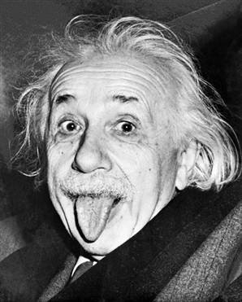

Time allowed: max 60 min
Answer all questions on the paper provided
To achieve full marks, clear, logical
working and diagrams MUST be shown.
Answers should be evaluated with an
appropriate number of significant figures.

Name
Score | /50

Section A: 4 questions worth 14marks

- Two identical atomic clocks of extreme accuracy are set to within the same nanosecond at Greenwich in England. One of the clocks is then flown to Perth at 800 km h⁻¹. In Perth the clock is now several nanoseconds different to its “twin” still at Greenwich.

- Is the clock in Perth ahead or behind its “twin”?

(b) Explain the difference with reference to any relevant principles.

(2 marks)

- Consider the two spectra A and B below. One of them is the spectrum of red laser light and the other of torchlight after it has passed through transparent red plastic. Indicate which spectrum is associated with which light source, and give a reason for each one?

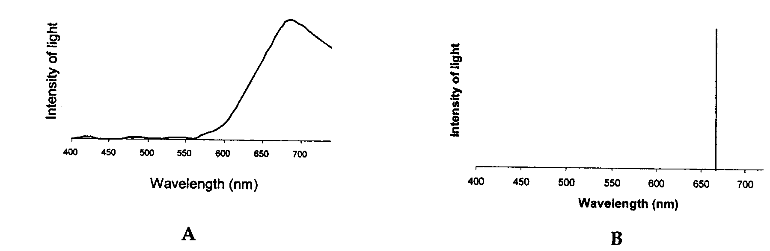

(4 marks)
- Strong nuclear forces hold protons and neutrons together. Protons and neutrons are hadrons and each hadron is made up of three quarks. There are six types of quarks each of which has a fractional charge. Up-type quarks have a charge of (+2/3) electric charge, while down-type quarks have (-1/3) electric charge. Using this information, determine the quarks that make up a neutron and a proton. You must show your working to justify your answer.

- a neutron

- a proton
(4 marks)
- Some minerals will show colours under ultra-violet light. What is the name of this phenomenon and how does it occur? Include a diagram with your answer.

(4 marks)

Section B: 5 questions worth 36 marks

- The following diagram shows a type of X-ray tube.
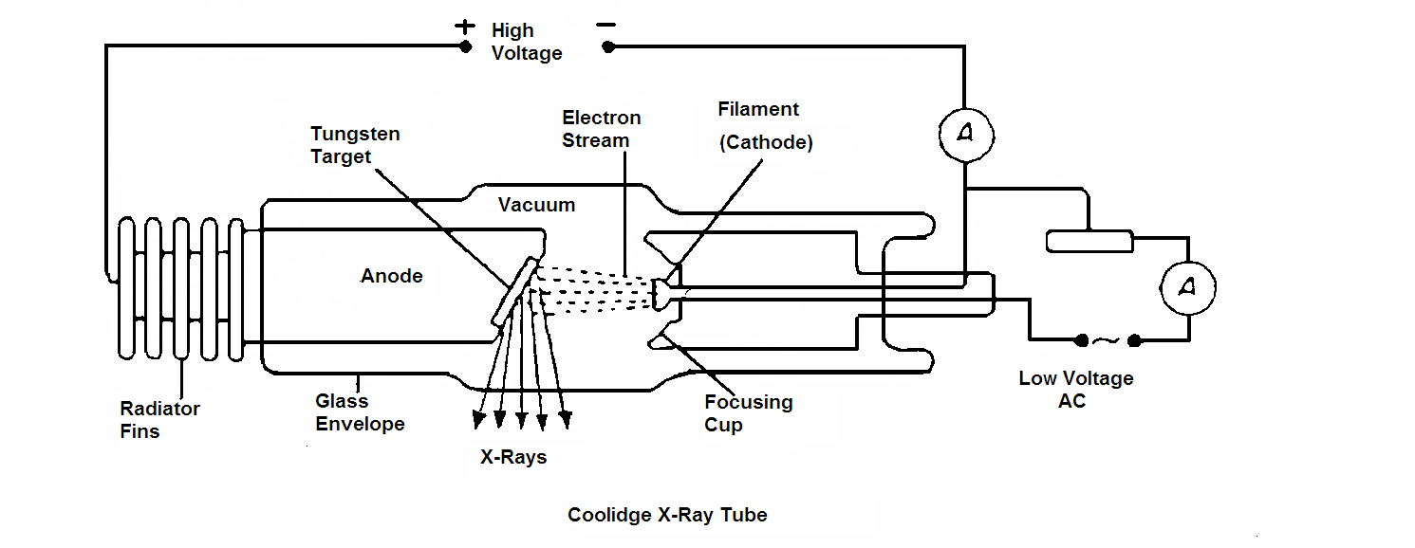

It can be used to produce hard X-Rays or less penetrating soft X-Rays.
- What adjustments can be made to this X-ray tube to change the wavelength of the X-Rays produced. Explain.

(2 marks)
- Several of the X-ray photons produced will be characteristic of the tungsten target. Explain how these are related to tungsten atoms?

(2 marks)
- If the high voltage is set at 55 kV, what is the maximum frequency of the X-Rays produced?

(4 marks)
- The energy levels of atomic sodium are shown below:
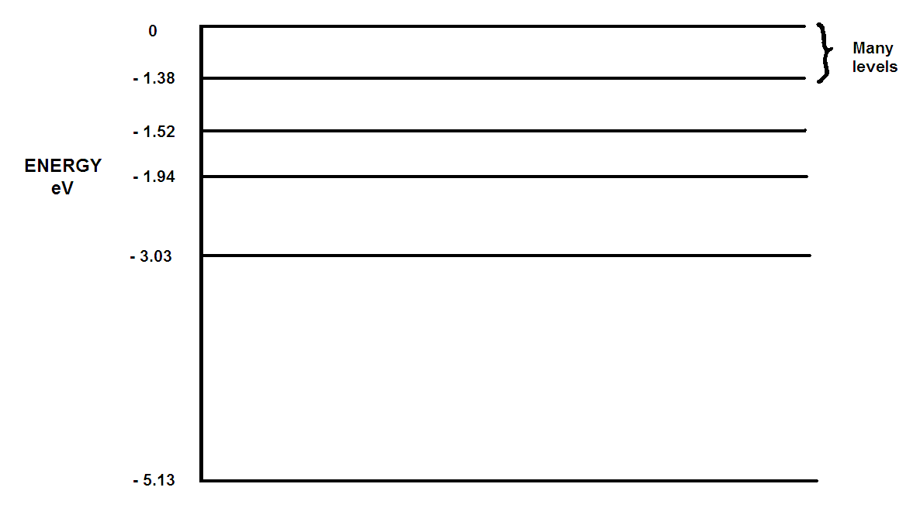

- Sodium atoms are bombarded with electrons of energy 3.50 eV. What will be the possible energy (or energies) of the photons emitted? (3 marks)

- What is the shortest wavelength of radiation that sodium vapour could emit? (Note: answer for any incoming value of energy)
(3 marks)

- Which transition accounts for the characteristic flame colour of sodium which has a wavelength of 5.89 x 10⁻⁷m?
(4 marks)

- Consider the following statement.
“The distances to different galaxies is proportional to red-shift of that galaxy with the more the red-shift, the further away the galaxy.”
This relationship is best known as __________________________ (1 mark)
- How does “red-shift” support the Big Bang Theory?

(3 marks)
- The Big Bang theory predicts that the universe is expanding.
Name and describe two possible futures for our universe.

(3 marks)

- Consider the following example which helps to explain Einstein’s special relativity.

John is standing in the middle of a train which is travelling very fast. John turns on a light at the instant the middle of the train passes Scott, who is standing on a platform. The diagram below shows this situation. Both John and Scott observe the movement of light towards each end of the train. With reference to the light striking the end walls of the train, describe:

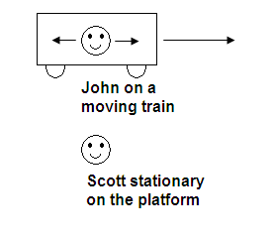
- What does John see happen?

(1 mark)
- What does Scott see happen?

(1 mark)

- Who is right, John or Scott? Explain your answer.

(2 marks)

- The following graph shows the factor by which mass increases with increasing velocity approaching the speed of light.

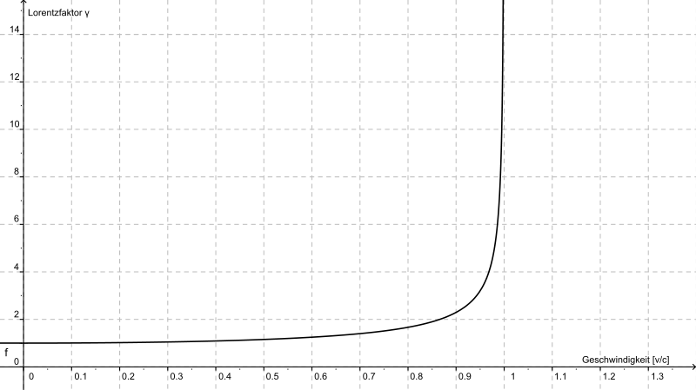
Mass increase (multiplier)
Velocity Ratio ( v/c )

A proton of mass 1.67 x 10⁻²⁷ kg is accelerated in the Large Hadron Collider until it reaches 0.95c
(c = speed of light).

- Using the graph, estimate the new mass (in kg) of the proton. (2 marks)

- What is the reason for this apparent increase in mass?

(1 mark)
Einstein derived the mathematical equation showing how mass changes with speed.
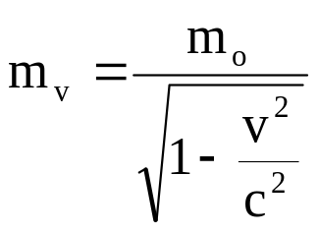
where m₀ is the rest mass and m_{v} is the mass when moving (in kg).

- Assuming that a proton is accelerated by the LHC to 0.99c, calculate the new mass of the proton when travelling at this speed.

(2 marks)

- Explain why it is theoretically impossible for the proton to travel at or faster than the speed of light?

(2 marks)

End of Test

